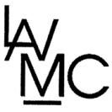
LOS ALAMOS VALLEY MEN'S CLUB
lavmc.org

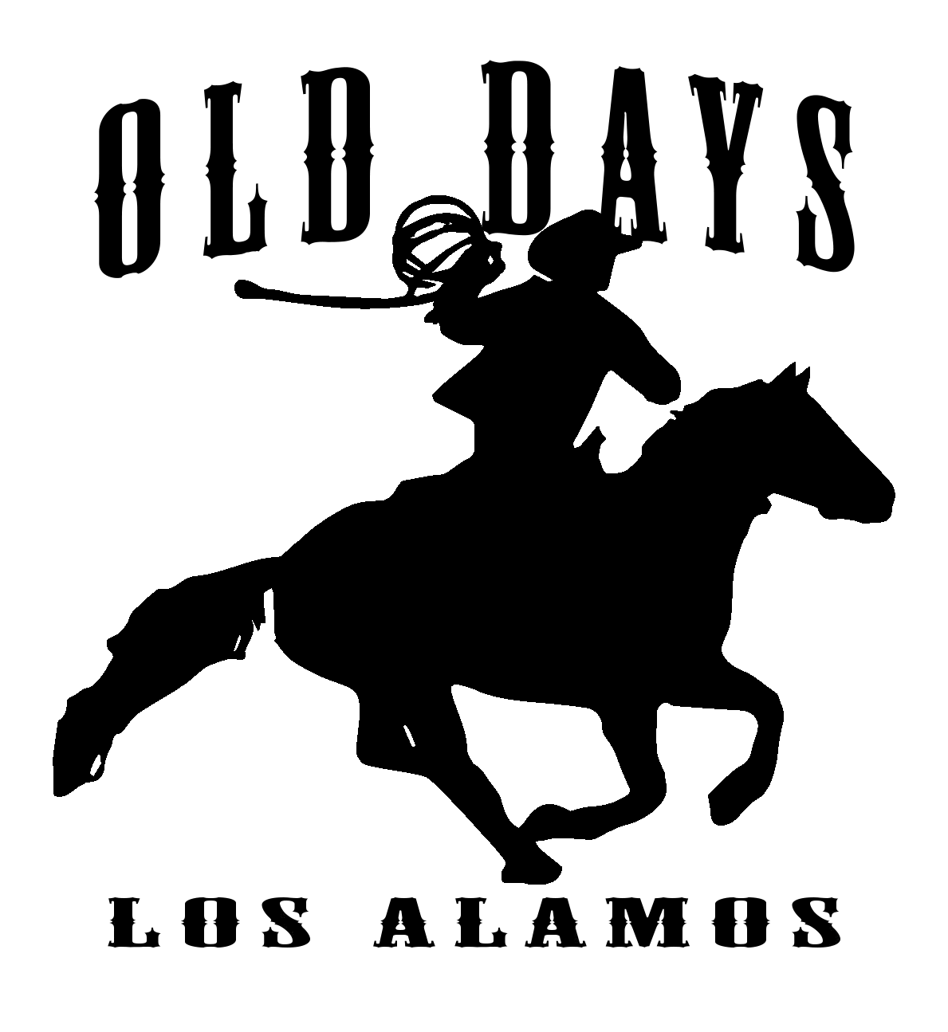
You are Invited to Join Us for the
2022 Los Alamos Old Days Parade
76th Annual Celebration
“Not Our First Rodeo”
Entry Due: by September 21, 2022
Parade Date: Sunday, September 25th, at 10 a.m. Registration fee: $15.00
***All sections must be complete, or application will be denied.
Please Print or type
Name/Description of entry: ____________________________________________________________
Contact Person: _____________________________________________________________________
Phone: __________________________ Email: ____________________________________________
Mailing address: _____________________________________________________________________
Number of people in group: ____________
*** Required: Please submit a brief description of your entry for the parade announcer. Please include names.
Please circle only one of the following themes which best describes your entry. No political group or politician will be considered for the judging. No stallions and no exceptions.
Best use of theme / Best junior equestrian / Best senior equestrian /Best equestrian group /Best military /Best community service organization / Best antique vehicle /Best classic vehicle / Best clown /Best performance group (musical, marching) / Best grammar school aged / Best high school aged /Best restored tractor /Best contemporary tractor / Best float (misc.) Staging Information:
The parade route begins on Centennial Street at Coiner Street (Near Olga Reed School). It will travel down Centennial towards Bell Street. The parade ends before Bell Street and the return route is as follows: Left on Waite Street then a left on St. Joseph Street. Follow St. Joseph to Coiner Street and make a left to return to Centennial Street staging area.
A check-in table will be located at Centennial and Coiner streets. Centennial will be closed to traffic. Use Bell Street to St Joseph to Coiner to reach the staging area near the elementary school.
Check in between 8:30 to 9:45. No entries accepted after 9:45. You will be assigned a parade number at check-in. Your entire entry group must be in place by 9:45. Parade begins at promptly at 10 a.m.
Registration fee can be a check made out to LAVMC and mailed with completed entry to: Los Alamos Old Days Parade P.O. Box 234 Los Alamos Ca 93440 *Returned checks incur a $25 charge and loss of parade entry. Registration fee can be sent using Venmo at: @LAVMC (Verification code is 6337) Write Parade Entry and your name in the note section.

Los Alamos Old Days
Not Our First Rodeo

Parade Rules
Complete and return forms and registration fee no later than September 21, 2022.
Early entries are appreciated!
- All participants must be uniformed, costumed, or appropriately dressed before the parade begins at 10 am.
- Entry number must be placed on the left side of entry or left arm of group leader.
- Certificates will be awarded for first place in each category and will be awarded to the winners before the parade begins. Participation ribbons will be given and must be worn by each entry.
- Forward motion must be maintained throughout the parade. Please stay in order of the number issued to you. Maintain 25 feet between you and entry in front of you. Be aware of the entry in front of you, if they stop then you must also stop to maintain the 25 feet between you.
- For everyone’s safety, throwing of any item is prohibited. No candy can be thrown.
- No alcohol of any type will be allowed in the parade or parade staging area.
- No equestrian riders under 10 without a lead line and an adult with them.
- All riders under the age of 16 must have an adult spotter between their horse and the crowd.
- We require groups with horses to have someone follow and clean up after their horses.
- Absolutely no stallions are permitted on the streets or in the parade. No exceptions. This will be enforced by Santa Barbara County Sheriff’s Deputies.
- If you find you are unable to participate after returning this form, please call Kristy at 805-610-3360, or email gnesa@aol.com.
- Any special requests regarding placement in the parade must be stated on your entry form and received before the deadline of September 21, 2022. We will do our best to comply but cannot guarantee your requested placement in the line-up.
**** My signature signifies that I have read and agree to the above parade rules. I hereby agree to hold harmless the Los Alamos Valley Men’s Club, its directors, members, or agents and the Los Alamos Old Day’s committee from any loss, damage, or injury resulting in my/our/group’s participation in this event.

Signed: ________________________________________________  Title: _________________________________________ | Date:
Signed: ________________________________________________ | Date:
Title: _________________________________________

****If an entrant is a minor, a parent or legal guardians’ signature is required.

